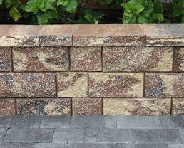

Wall Installation Guide
Cumbria Wall without Geosynthetic Reinforcement

Cumbria Installation Guide
(without geosynthetic reinforcement)
Typical Wall Cross-section

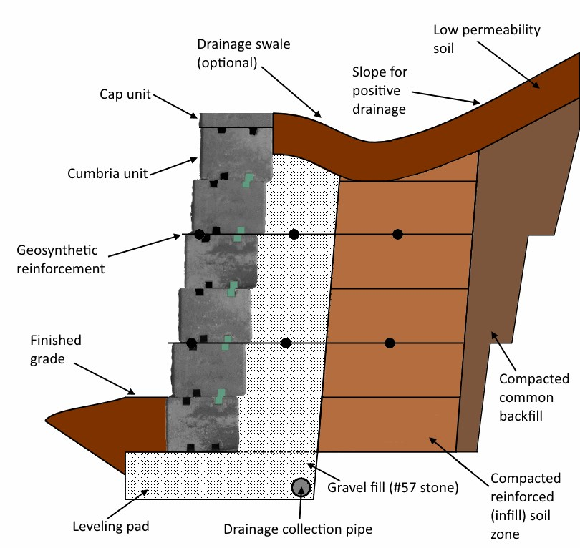
Base Preparation: To start, lay out and mark where you want the front of the retaining wall. Excavate the area by removing all surface vegetation and other organic materials. Dig a base trench the length of the wall and 20 inches wide; the depth of the trench should be 6 inches. Compact the subgrade soil thoroughly and line excavated area with landscape fabric.
Leveling Pad: Fill the trench with #57 stone to create a leveling pad. Ensure that the gravel is densely compacted using a plate compactor.
Drainage Pipe Installation: Place a proper drainage pipe to direct water away from the wall. There are different drain pipe installation options, depending on the site conditions. See Figure 1.
Figure 1
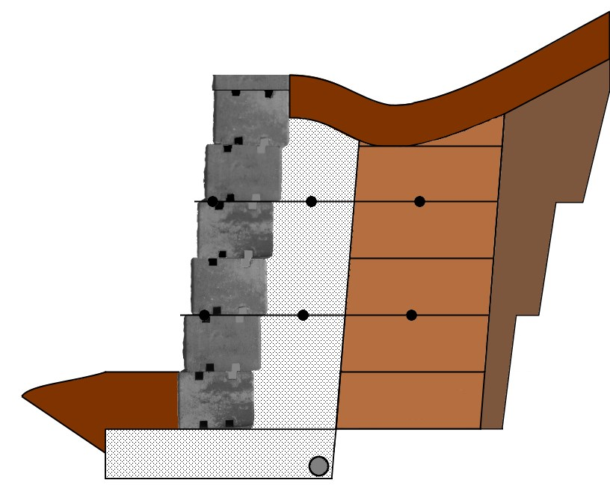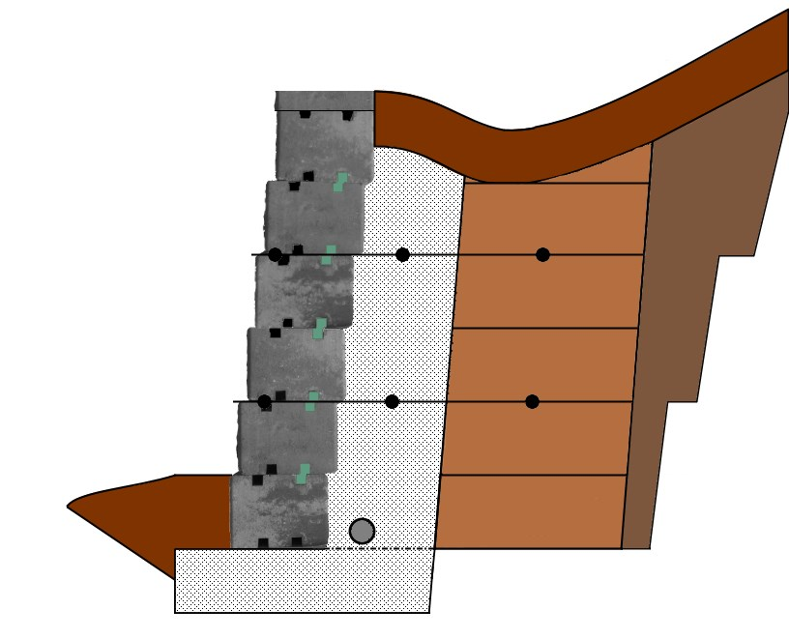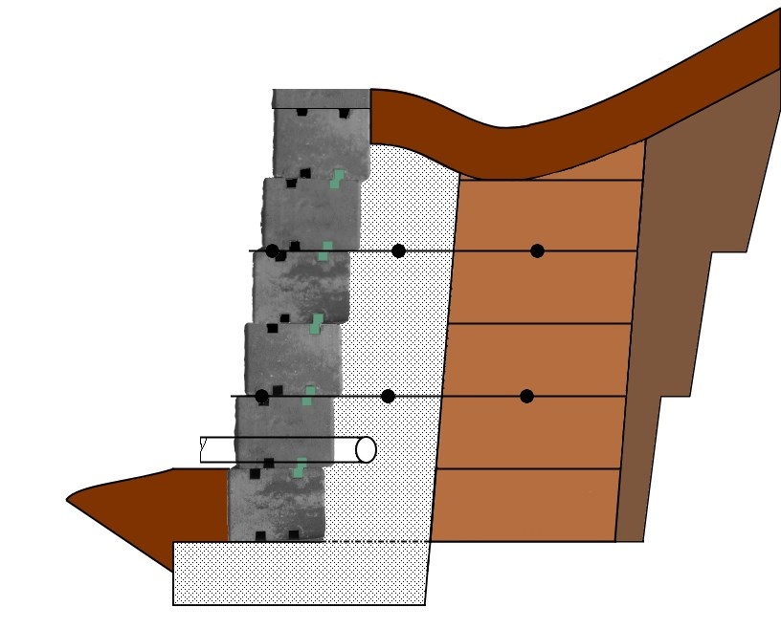
Drain pipe installed in compacted Drain pipe installed behind first Drain pipe installed at a higher
clean gravel. block. elevation through the wall face.

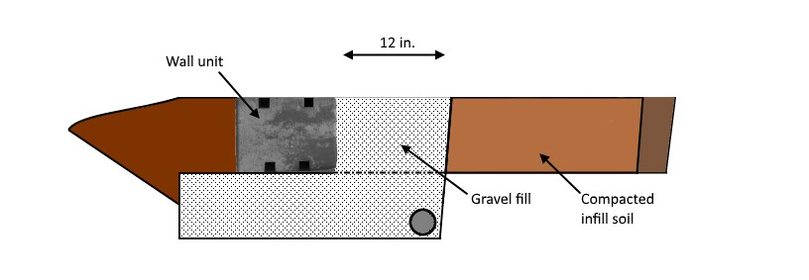
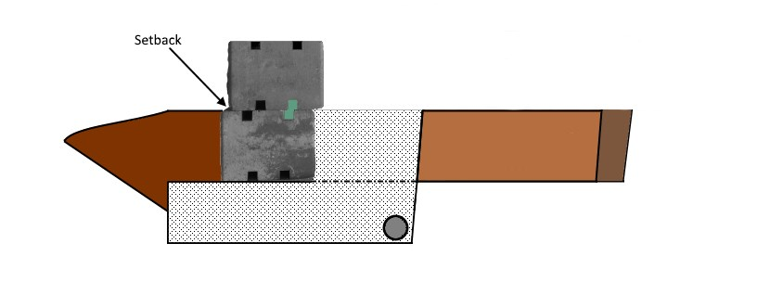
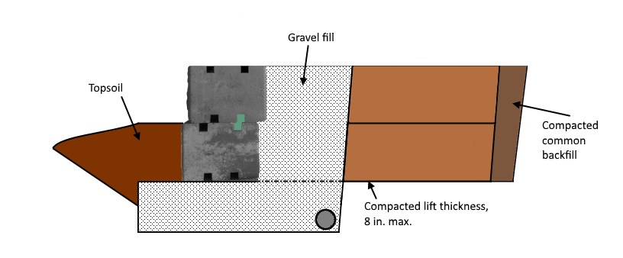
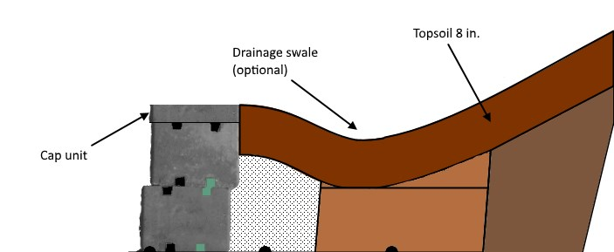

Place and level the first course of wall units on the base. It is very important to get the first row completely level before you continue building.
Carefully lay out clean gravel behind and up to the height of the wall unit to create a wall-face drain. Place and compact infill soil behind wall-face drain. Next, add infill soil in front of the wall unit. Compact the gravel and infill soil.

Ensure gravel fill is level with, or slightly below, the top of the wall unit. Clean off any debris from the top unit. Set connectors and move wall unit into place, no mortar needed. Ensure the wall has the proper setback.

Use gravel to fill behind and up to the height of the wall unit to continue the wall-face drain. Spread and compact infill soil behind the drain. Compact both the gravel and the soil.

Once you are at your desired height, put down the cap unit and secure it with adhesive. Finish wall grading to direct water away from the wall. (Optional swale)

Cumbria Connectors and You

- Easy Installation
Forget the mess of mortar; connectors make wall installation a breeze. Using connectors instead of mortar means your wall will be easy to modify and have a wide range of design capabilities.

- Design Flexibility
The structural design of Cumbria walls paired with the connector system allows you to design and build practically any idea you can create, including curves and corners.

- Simple Modification
Cumbria walls and corners can be easily modified to suit your design needs. These solid units can simply be split on-site, meaning no special blocks are needed.

- Stability and Durability
Using connectors allows Cumbria walls to be stacked in three different ways: setback, stacked, and protruding; giving you the capability to create the most stable wall for your site. Cumbria walls are easily compatible with geosynthetic reinforcement and are solid units to keep your wall standing for a lifetime.

- Free-draining Wall
While mortaring your wall blocks together inhibits natural drainage through the wall face, using connectors leaves small spaces for water to leave the soil behind your retaining wall. Water and improper drainage is often the cause for wall failure; getting maximum drainage is the goal.

Visit us @ www.tricirclepavers.com
Cumbria Wall

Protruding

Place two connectors, as shown in the images, in the front slot facing towards the front of the block.

Stacked
Place two connectors, as shown in the images, in the front slot facing towards the back of the block.

Setback
Place two connectors, as shown in the images, in the back slot facing towards the back of the block.

Colors Sizes
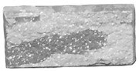
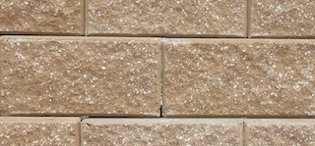
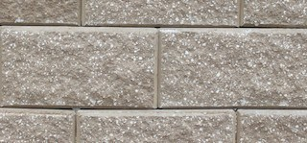
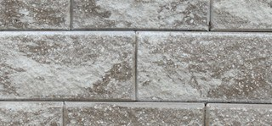
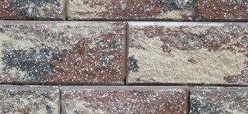
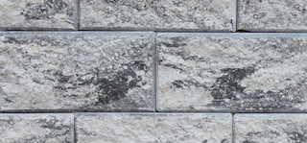
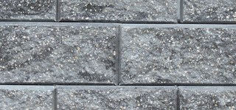
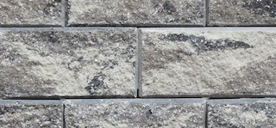
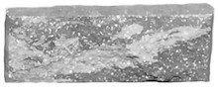
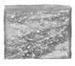
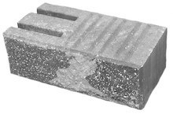

TriCircle Pavers, Inc. – Ft. Myers
2709 Jeffcott Street
Fort Myers, FL 33901
TriCircle Pavers, Inc. – Bartow
3311 Noralyn Mine Road
Bartow, FL 33830

